

***SUBMITTED BY***

S.M.SHAYAN HUSSAIN ZAIDI

(

946

-

2018

)

WALEED AZHER KIDWAI

(

943

-

2018

)

SADIQ

-

UL

-

AMIN

(

828

-

2018)

***TEACHER NAME***

MR.FAHEEM AHMED



**EVENT**

**MANAGEMENT SYSTEM**

**SEMESTER**

**REPORT**

**2019**

**HAMDARD UNIVERSITY**

IN PERSUIT OF EXCELLENCE

# HAMDARD UNIVERSITY

## IN PERSUIT OF EXCELLENCE

**TABLE OF CONTENT**

1. Acknowledgement.................................. 3

1. Abstract.......................................... 4

1. Introduction........................................ 5

1. Features of the project............................... 6-8

1. Program for Event Management System................ 18

1. Conclusion........................................ 19

# HAMDARD UNIVERSITY

## IN PERSUIT OF EXCELLENCE

### ACKNOWLEDGEMENT

We thank **Mr. MOHSIN KHAN** who have been the great inspiration and who have provided sufficient background knowledge and understanding of the subject Programming fundamental.

Our humble prostration goes to our H.O.D. **Dr. FARHA ADEEBA** for providing all the necessary resources and environment, which have aided us to complete this project successfully.

We feel privileged to extend our deep sense of gratitude to our parents for their support and encouragement. Finally yet importantly, we would like to thanks our class friends for their support in completing the project.

### ABSTRACT

This report is an introduction to the Event Management System in Python programming. Anybody, who does not know even the basics of Event Management System in Python, will be certainly able to understand and gain the great knowledge from this report. The core theme of the report focuses on the development of Event Management System in Python Programming language.

Event Management System is a well-prepared system to manage the details of events. It manages all the information about booking of events and of the peoples, booking the tickets for their desire events.

### INTRODUCTION

This is a Python based Event Management project. This system provides various options like book an event, book tickets of the events, view all events, view total tickets that are sell out and their information. The project is developed using two important Pythons concepts that are classes and file handling.

The project is totally built at administrative end and thus only the administrator is guaranteed the access. The purpose of the project is to build an application program to reduce the manual work for managing the booking of events and collect the records of number of peoples coming to those events

### Features of project

❖

**CREAT AN EVENT**

**:**

❖

**VIEW AN EVENT**

**:**

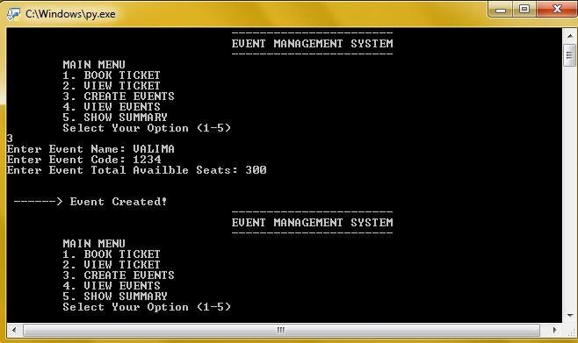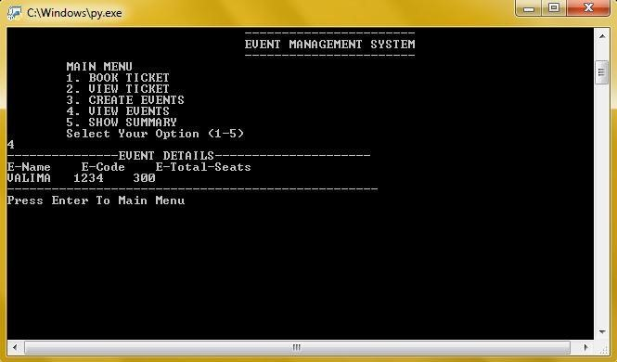

❖

**BOOK A TICKET**

**:**

❖

**VIEW TICKETS :**

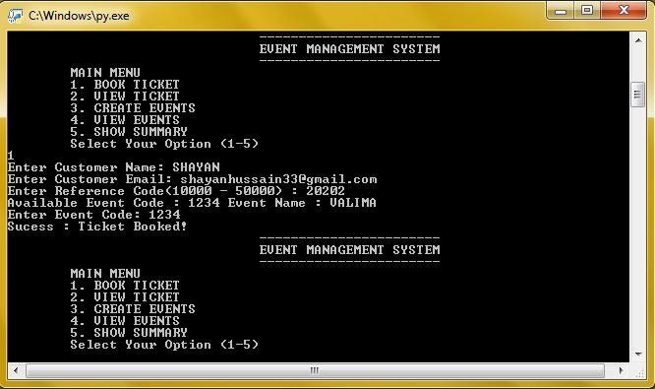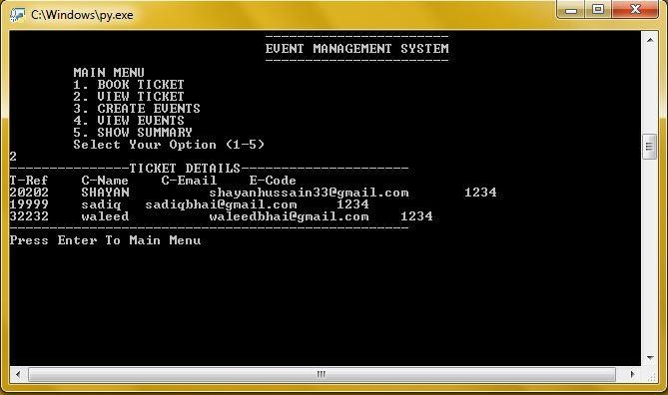

❖ **TOTAL SUMMARY OF BOOKED TICKETS:**

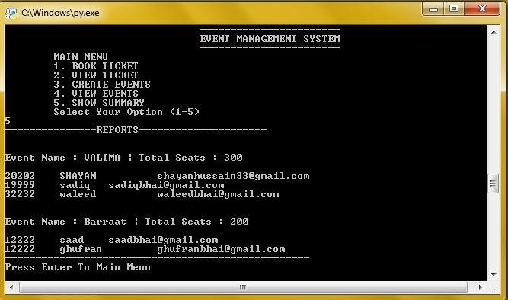

# HAMDARD UNIVERSITY

## IN PERSUIT OF EXCELLENCE

### PROGRAM FOR EVENT MANAGEMENT SYSTEM

# Event Management System

# Features :

# 1. Create An Event

# 2. View Events

# 3. Book Ticket

# 4. View Ticket

# 5. Condition Check If Customer Already Buy Same Event Ticket

# 6. Condition Check if All Tickets are sold Out.

# 7. Show Overall Event Summary

import pickle #Python pickle module is used for serializing and de-serializing a Python object structure import os import pathlib

############################### Book a Ticket Class

class Ticket: name = '' email = '' event = '' reference = 200000

def bookTicket(self):

self.name= input("Enter Customer Name: ") self.email = input("Enter Customer Email: ") file = pathlib.Path("events.data")

if file.exists():

infile = open('events.data', 'rb') eventdetails = pickle.load(infile)

self.reference = input("Enter Reference Code(10000 - 50000) : ") while True: if int(self.reference) <= 10000:

print("Warning: Please Enter Valid Reference Code") self.reference = input("Enter Reference Code(10000 - 50000) : ")

else:

break

for event in eventdetails:

print("Available Event Code : " + event.eventcode + " Event Name : " + event.eventname)

infile.close() self.event = input("Enter Event Code: ") def check(self):

file = pathlib.Path("tickets.data") if file.exists():

infile = open('tickets.data', 'rb') ticketdetails = pickle.load(infile) for ticket in ticketdetails: if ticket.email == self.email and ticket.event == self.event:

return True infile.close()

def gettotalticketcount(self):

file = pathlib.Path("events.data")

if file.exists():

infile = open('events.data', 'rb') eventdetails = pickle.load(infile) for event in eventdetails: if event.eventcode == self.event:

return int(event.eventTotalAvaibleSeat) infile.close else:

return 0

def getBookedSeatCount(self): file = pathlib.Path("tickets.data") counter= 0

if file.exists():

infile = open('tickets.data', 'rb') ticketdetails = pickle.load(infile) for ticket in ticketdetails: if ticket.event == self.event: counter = counter + 1 return int(counter) return 0

############################ Create Event Class

class Event: eventname = '' eventcode = '' eventTotalAvaibleSeat = 10

def createEvent(self):

self.eventname= input("Enter Event Name: ") self.eventcode = input("Enter Event Code: ") self.eventTotalAvaibleSeat = input("Enter Event Total Availble Seats: ") print("\n\n ------> Event Created!")

############################################## Main Program Modules

# Book Ticket and Check Condition

def bookEventTicket(): ticket = Ticket() ticket.bookTicket() if ticket.check():

print("Warning : You Already Book A Seat")

elif ticket.getBookedSeatCount() >= ticket.gettotalticketcount():

print("Warning : All Ticket Sold Out")

else:

print("Sucess : Ticket Booked!") saveTicketDetiails(ticket)

# Save Ticket Detials to File

def saveTicketDetiails(ticket): file = pathlib.Path("tickets.data") if file.exists():

infile = open('tickets.data', 'rb') oldlist = pickle.load(infile) oldlist.append(ticket) infile.close() os.remove('tickets.data') else:

oldlist = [ticket]

outfile = open('tempTicket.data', 'wb') pickle.dump(oldlist, outfile) outfile.close() os.rename('tempTicket.data', 'tickets.data')

# Display Saved Ticket Details

def getTicketDetails():

file = pathlib.Path("tickets.data") if file.exists ():

infile = open('tickets.data','rb') ticketdetails = pickle.load(infile) print("---------------TICKET DETAILS---------------------") print("T-Ref C-Name C-Email E-Code") for ticket in ticketdetails :

print(ticket.reference,"\t",ticket.name,"\t", ticket.email, "\t",ticket.event) infile.close() print("--------------------------------------------------")

input('Press Enter To Main Menu')

else :

print("NO TICKET RECORDS FOUND")

# Create Event Module

def createEvent():

event = Event() event.createEvent() saveEventDetails(event)

# Save Event Details to File

def saveEventDetails(event): file = pathlib.Path("events.data")

if file.exists():

infile = open('events.data', 'rb') oldlist = pickle.load(infile) oldlist.append(event) infile.close() os.remove('events.data') else:

oldlist = [event] outfile = open('tempevents.data', 'wb') pickle.dump(oldlist, outfile) outfile.close() os.rename('tempevents.data', 'events.data')

# Display All Event Details

def getEventsDetails():

file = pathlib.Path("events.data")

if file.exists ():

infile = open('events.data','rb') eventdetails = pickle.load(infile) print("---------------EVENT DETAILS---------------------") print("E-Name E-Code E-Total-Seats") for event in eventdetails :

print(event.eventname,"\t", event.eventcode, "\t",event.eventTotalAvaibleSeat)

infile.close() print("--------------------------------------------------")

input('Press Enter To Main Menu')

else :

print("NO EVENTS RECORDS FOUND")

# Display Reports About Events

def getEventsSummary():

filetickets = pathlib.Path("tickets.data") if filetickets.exists():

infiletickets = open('tickets.data', 'rb') ticketdetails = pickle.load(infiletickets)

fileEvents = pathlib.Path("events.data") if fileEvents.exists ():

infileEvents = open('events.data','rb') eventdetails = pickle.load(infileEvents) print("---------------REPORTS---------------------") for event in eventdetails :

print("\n\nEvent Name : " + event.eventname + " | Total Seats : " + event.eventTotalAvaibleSeat +

" \n") for ticket in ticketdetails: if event.eventcode == ticket.event:

print(ticket.reference, "\t", ticket.name, "\t", ticket.email)

infileEvents.close() infiletickets.close()

print("--------------------------------------------------")

input('Press Enter To Main Menu')

else :

print("NO EVENTS RECORDS FOUND")

###################################################### Start Program

ch=''

num=0

while ch != 8:

print("\t\t\t\t-----------------------")

print("\t\t\t\tEVENT MANAGEMENT SYSTEM")

print("\t\t\t\t-----------------------")

print("\tMAIN MENU") print("\t1. BOOK TICKET") print("\t2. VIEW TICKET") print("\t3. CREATE EVENTS") print("\t4. VIEW EVENTS") print("\t5. SHOW SUMMARY") print("\tSelect Your Option (1-5) ") ch = input()

if ch == '1': bookEventTicket() elif ch == '2': getTicketDetails() elif ch == '3': createEvent() elif ch == '4': getEventsDetails() elif ch == '5':

getEventsSummary()

# HAMDARD UNIVERSITY

## IN PERSUIT OF EXCELLENCE

### CONCLUSION

At the beginning of this project, we want to make a Management System of an Event and at the end of this project we made this. After preparing the papers, we got the answers of the following questions:

* What is Event Management System?
* Is it possible to run the whole management system into Computer?
* How Events can be classified?
* What are the different types of events that can be arranged?
* What are the main responsibilities of an Event management professional?
* How will you handle large groups of ongoing events?